‘Match them up’ fire extinguisher card game.

Cut out and re-order the cards.

Powder | For wood, paper, textiles, flammable liquid, gaseous fires, live electrical equipment | Can be used on most fires.  May leave a residue on surfaces after use that is hard to remove. | 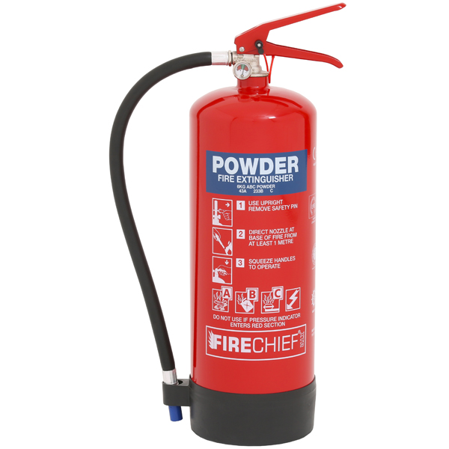
Water | For wood, paper & textile fires. | DO NOT USE ON flammable liquid and live electrical equipment fires. | 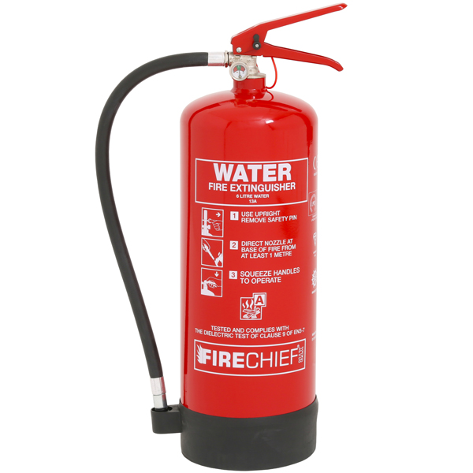
C02 | For use on flammable liquid fires and live electrical equipment | DO NOT USE ON wood, paper, textile or flammable metal fires.  DO NOT USE in a confined space. | 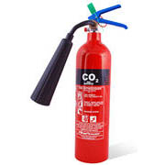
Foam | For use on flammable liquid, wood, paper and textile fires. | DO NOT USE ON live electrical equipment or metal fires. | 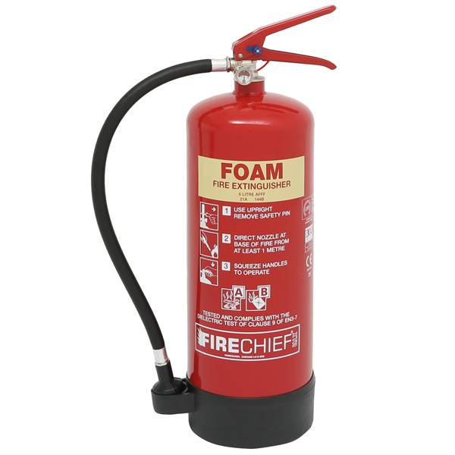
Wet  Chemical | For use on wood, paper, and textiles fires.  They can also be used on cooking oil fires. | Not effective on flammable gasses type fires. | 